**EARN WHILE LEARN**

A Minor Project Report Submitted To



Rajiv Gandhi Proudyogiki Vishwavidyalaya, Bhopal

Towards Partial Fulfillment For The Award Of

Bachelor of Engineering

In

**DEPARTMENT COMPUTER SCIENCE AND ENGINEERING**

Submitted By

**AASTHA KATIYAR (0863CS151001)**

**DIKSHA SHIVHARE (0863CS151001)**

**MD. ARBAZ WARSI (0863CS151001)**

Under The Supervision Of

**DR. MANOJ KUMAR DESHPANDE**

**PROF. ATISH MISHRA**

Session: 2017-2018

Department Of Computer Science And Engineering,

**Prestige Institute Of Engineering, Management And Research,**

Indore (M.P.)

[An Institution Approved By AICTE, New Delhi & Affiliated To RGPV, Bhopal ]

**PRESTIGE INSTITUTE OF ENGINEERING MANAGEMENTAND RESEARCH**

**INDORE (M.P.)**

**DECLARATION**

We Aastha Katiyar, Diksha Shivhare, Md. Arbaz Warsi hereby declare that the project entitled “EARN EHILE LEARN”, which is submitted by us for the partial fulfillment of the requirement for the award of Bachelor of Engineering in Computer Science & Engineering to the Prestige Institute of Engineering, Management and Research, Indore (M.P.)*.*Rajiv Gandhi Proudhyogiki Vishwavidyalaya, Bhopal, comprises my own work and due acknowledgement has been made in text to all other material used**.**

Signature of Students:

Date:

Place:

**PRESTIGE INSTITUTE OF ENGINEERING MANAGEMENTAND RESEARCH**

**INDORE (M.P.)**

**DISSERTATION APPROVAL SHEET**

This is to certify that the dissertation entitled **“EARN WHILE LEARN”** submitted by Aastha Katiyar, Diksha Shivhare, Md. Arbaz Warsi, to the Prestige Institute of Engineering, Management and Research, Indore (M.P.) is approved as fulfillment for the award of the degree of “Bachelor of Engineering in Computer Science & Engineering” by Rajiv Gandhi Proudhyogiki Vishwavidyalaya, Bhopal, (M.P.).

**Internal Examiner: External Examiner:**

Date: Date:

**HOD, CSE**

**PIEMR, INDORE**

**PRESTIGE INSTITUTE OF ENGINEERING MANAGEMENTAND RESEARCH**

**INDORE (M.P.)**

**CERTIFICATE**

This is certified that project entitled “EARN WHILE LEARN” submitted by Aastha Katiyar (0863cs151001), Diksha Shivhare (0863cs151001), Md. Arbaz Warsi (0863cs151001), is a satisfactory account of the bona fide work done under our supervision and is recommended towards partial fulfillment for the award of the degree Bachelor of Engineering in Computer Science & Engineering to Rajiv Gandhi Proudyogiki Vishwavidyalaya, Bhopal (M.P.) .

Date:

Enclosed by:

( ) ( )

Project Guide Project Incharge HOD (CSE)

**( )**

**PRINCIPAL**

**PIEMR, Indore**

**(M.P.)**

**PRESTIGE INSTITUTE OF ENGINEERING MANAGEMENTAND RESEARCH**

**INDORE (M.P.)**

**ACKNOWLEDGEMENT**

After the completion of minor project work, words are not enough to express my feelings about all these who helped me to reach my goal; feeling above this is my indebtedness to the almighty for providing me this moment in life.

First and foremost, I take this opportunity to express my deep regards and heartfelt gratitude to my project guide **Dr. Manoj Kumar Deshpande, Director, PIEMR, Indore, Prof. Atish Mishra, Asst. Prof. Department of Computer Science and Engineering, PIEMR, Indore** for their inspiring guidance and timely suggestions in carrying out my project successfully. They are also the constant source of inspiration for me. Working under their guidance has been an opportunity for me to learn more and more.

I am extremely thankful to **Prof. Nidhi Arora, (HOD, CSE)** for her co-operation and motivation during the project. I extend my deepest gratitude to **Dr. Manoj Kumar Deshpande, Director, PIEMR, and Indore** for providing all the necessary facilities and true encouraging environment to bring out the best of my endeavors.

I would like to thank all the teachers of our department for providing invaluable support and motivation. I remain indebted to all the non-teaching staff of our Institute who has helped me immensely throughout the project.

I am also grateful to my friends and colleagues for their help and co-operation throughout this work. Last but not least; I thank my family for their support, patience, blessings and understanding while completing my project.

**Name of Students**

**AASTHA KATIYAR**

**DIKSHA SHIVHARE**

**MD. ARBAZ WARSI**

**TABLE OF CONTENTS**

**Declaration I**

**Dissertation Approval Sheet II**

**Certificate III**

**Acknowledgement IV**

**Table of Contents V**

**List of Tables VI**

**List of Figures VII**

# Chapter 1 Introduction 1

1.1 Introduction 2

1.2 Motivation

1.3 Objective

1.4 Analysis

1.4.1 Functional Requirements

1.4.2 Non-functional Requirements

1.4.3 Use Case Diagram

# Chapter 2 Background and Related Work

2.1 Problem Statement

2.2 Background and Related Work

2.2.1 Background Work

2.3 Solution Approach (*methodology and technology used)*

# Chapter 3 Design (Complete UML and Data modeling)

3.1 UML Modeling

3.1.1 Sub Systems

3.1.2 Modules Specification

3.1.3 Collaboration Diagram

3.1.4 Class Diagram

3.1.5 Sequence Diagram

3.1.6 Activity Diagram

3.2 Data Modeling

3.2.1 ER Diagram

3.2.2 Data Flow Diagram

# Chapter 4 Implementation (details with syntax if required, Core logic/algorithm/code)

4.1 Tools Used

4.2 Testing

4.2.1 Testing Approach

4.2.2 Test Cases

4.2.3 Test Reports

4.3 User Manual

# Chapter 5 Project Plan

5.1 Gantt Chart

5.2 Effort Schedule & Cost estimation

5.3 Work Breakdown Structure

# Chapter 6 Conclusion/ Future Scope

6.1 Conclusion

6.2 Future Scope

**Bibliography**

**Appendix A: Snapshots or Screenshots with description**

**CHAPTER 1**

**INTRODUCTION**

# 1.1 Introduction:

# “Earn while learn” is a *web application,* developed in “ruby on rails” which connects employers and job seekers where employers are the source of the resources and the job seeker can find and apply for their targeted job.

# It is formed with the help of *rails* which is the frame work of *ruby* programming language. By this website one can make money by part time and full time jobs also, even sitting at home and even in the student life.

# Motivation:

# The Earn while learn provides opportunities to the students to earn, while they are learning(studying), through the part-time jobs and the entrepreneurial projects thus preparing them to shoulder professional assignments with relative ease.

## 

# 1.3 Objective:

“EARN WHILE LEARN” is a package to be used by agencies to improve the efficiency of business. The system provides jobs catalogue and information to members and helps them decide on the jobs to apply. The Admin can keep the jobs catalogue updated all the time so that the members (Job seekers and the agencies) get the updated information all the time.

The purpose of the application is to provide job portal for job seeker, to submit their CV and apply for job, where Employer can select best employee from available candidate profile.

* Registration
* Login
* Authenticating
* Updating Profile
* Posting a job and removing or modifying job
* Searching for a job
* Taking online exam
* Feedback

# 1.4 Analysis

## 1.4.1 Functional Requirements:

### Functional requirements:

The website should be functions as well at the end of users, employers, and admin.

### ADMIN:

* Admin manages employers and jobseeker’s profile.
* Admin manages payments for both employers and jobseekers.
* Admin adds a new service related to employer and job seekers.
* Admin sends messages to employer and job seeker.
* Admin provides roles and authentication to users.
* Admin displays the most recent jobs should be available on the home page.
* Admin can add/delete/approve/disapprove any jobs and employees as well as job seekers.

### EMPLOYEER:

* Employer can post a job.
* Employer can register/sign in/log in.
* Can send the e-mail to job seekers.
* Update and view profile anytime.
* Employer can view resume of any candidate.
* Employer can approve/disapprove a candidate.
* Reporting information on how much vacancies are available fulfilled and list of registered job seeker on that side.
* Payment by invoice/credit card.
* New account addition/deletion.

### JOB SEEKER:

* Job seeker can view all vacancies and job plans available.
* Job seeker can view the details of the company.
* Job seeker can login in and Apply for job.
* Job seeker can update his/her profile information.
* Job seeker can cancel member registration.
* Job seeker can view his/her Inbox.
* Job seeker can search the job and apply for job.

## 1.4.2 Non-functional Requirements:

## Non functional requirements:

### Performance:

* Better component design to get better performance at peak time.
* The product shall be based on web and has to be run from a web server.
* The product shall take initial load time depending on internet connection strength which also depends on the media from which the product is run.
* The performance shall depend upon hardware components of the client/customer.

### Reliability:

* The site will be reliable it can give service to the entire customer to their satisfactory end.
* The system shall use secure sockets in all transactions that include any confidential customer information.
* The system shall provide storage of all databases on redundant computers with automatic switchover.
* The system shall provide for replication of databases to off-site storage locations.

### Availability:

24*7 availability of the website whenever and wherever. System will remain inaccessible to users’ at2:00 to 4:00 am for backup and maintenance purposes.

### Security:

### Secure access of confidential data (user’s details.)

* The system shall automatically log out all customers after a period of inactivity.
* The system shall confirm all transactions with the customer’s web browser.
* The system shall not leave any cookies on the customer’s computer containing the user’s password.
* The system shall not leave any cookies on the customer’s computer containing any of the user’s confidential information.
* The customer’s web browser shall never display a customer’s credit card number after retrieving from the database. It shall always be shown with just the last 4 digits of the credit card number.

### Maintainability:

Flexible service based architecture will be highly desirable for future extensions.

### Portability

Software should be portable.

## 1.4.3 Use Case Diagram:

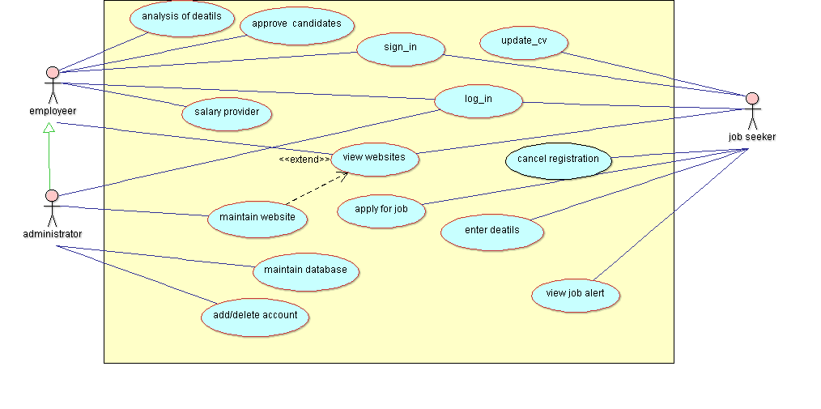

**CHAPTER 2**

**BACKGROUND**

**AND**

**RELATED WORK**

# 2.1 Problem Statement:

## 2.1.1 **Existing System**:

## Our existing system is work fully manually.

## In a manual system, Jobseeker can all work on paper so it is very time consuming process

## When new member are include then paper work will be automatically increased.

## All job search manually because the company are connected with admin.

## The Jobseeker who want to apply for specific Job .it’s hard to find as per specification

## 2.1.2 Need for new system:

* Application will provide the separate user account, which are used to upload resume, update profile and apply for multiple job.
* Provide easy and quick search of job from this application.
* This application provide user on criteria that is alone by specific user account
* User can update profile and resume for different types of job category.

# 2.2 Background and Related Work

## 2.2.1 Background Work:

### Literature Survey:

Case studies for Naukari.com, baba.com, shine.com. They brought the revolution of online job portals, form traditional way of job searching to technical advancement.

There are many applications developed related to this Online Job Portal, but, however, these systems are very complex for their own purpose. Most of them do not have the centralized database and easy access to users. So in this project, we are implementing this application through a centralized database and easy-to-use access for job seekers and job providers. The administrator is the primary actor to maintain the database, and also accepts comments from job providers and job seekers to improve and develop the application’s graphical user interface. Registered job seekers can also take the company online exam. In addition, qualified applicants can be classified according to this system based on their qualifications and company requirements.

## 2.3 Solution Approach (*methodology and technology used):*

We have user iterative model for our website.

* Job seeker will register on the site.
* Employers will post the jobs.
* Job seeker will browse the job by logging/ signing up..
* If he interested, he will apply for job.
* Employer will view profile of jobseeker and will accept/deny him/her for job.
* After getting confirmed, employer will send an email to job seeker as well as admin to inform about the scheduled interview., and vacancy will be removed from the site.

# Server Side Requirements:

|  |  |
| --- | --- |
| Processor | Any dual core greater than 1.6 GHz |
| RAM | 2 GB |
| Storage | 100MB increasing by Database |

# Client Side Requirements:

|  |  |
| --- | --- |
| Processor | Single core at least 0.8 GHz |
| RAM | 256 MB |

# Server Side Requirements:

|  |  |
| --- | --- |
| Operating System | Linux based x86/x64, Debian, Redhat based |
| Web Server | Puma |
| Run Time environment | Ruby, CSSengine3, Bootstrap, Rails5, HTML |
| Back End Tool | Sqlite3(development), postgresql(production) |

# Client Side Requirements:

|  |  |
| --- | --- |
| Operating System | All Linux, Windows XP,MAC |
| Web Browser | Google Chrome, Firefox, Internet Explorer 9+ |

# Software Used in Development:

* Operating System : Ubuntu 16
* Text Editor/IDE: Sublime text 3
* UML Modelling tool : ArgoUML : 0.34
* ER diagram: Smart Draw (Online ER diagram tool)

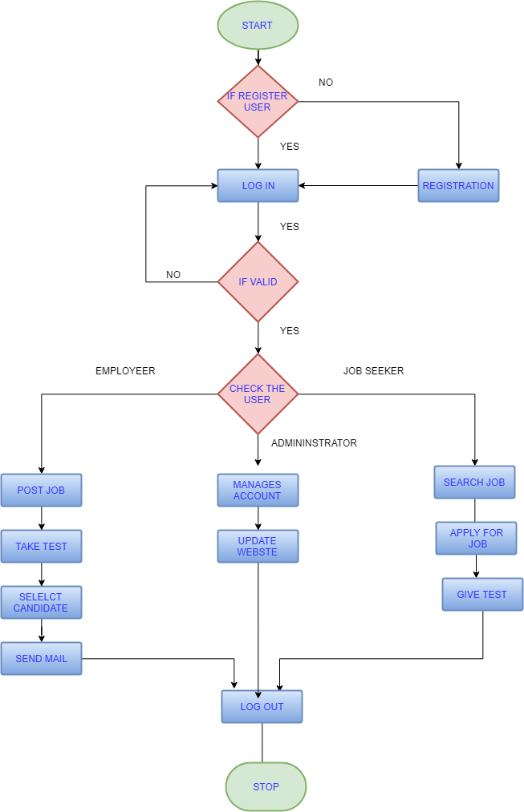

**CHAPTER 3**

**DESIGN**

# 3.1 UML Modeling

## 3.1.1 Sub Systems:

This project has many sub systems. Like it has log in forms for all type of users, email notification, interview, job posting by employer, admin’s website and database,

## 3.1.2 Modules Specification:

This section will describe function of actors, their roles in the system and constraints faced by the system.

* **Name of module:-**ADMINSTRATOR.
* **Descriptions:-**To manage the user accounts and maintain the database and user accounts.
* **Pre-conditions:-**administrator user name and password.
* **Normal flow of events:-**New login, password, details of the user location id, permissions are granted. Save details. Manage the permissions of other users.
* **Alternative flow of events:-**If login is wrong then message appears.
* **Post conditions:-**Management of user accounts and permissions.
* **Name of module:-**JOB SEEKER
* **Descriptions:-**Job seeker can register & login to the website and can upload his resume and can search for a desired job followed by applying for it.
* **Pre-conditions**:-Must have prepared his resume. Must be eligible to apply for a job.
* **Normal flow of events:-**

1. Enter the details and submit.
2. Log in the site.
3. Upload a resume search for a job.
4. Apply for a job.

* **Alternative flow of events:-**

1. Invalid username.
2. Invalid password.
3. Not eligible for the job.
4. Not job is available for which the seeker is eligible no vacancies in any company have already applied for all the vacancies

* **Post conditions:-**

User can regularly check his mails for the alerts (if any) send by the administrator.

* **Name of module:-** EMPLOYER
* **Descriptions:-**Job Provider can register & login to the website and can add the vacancies update and delete them.
* **Pre-conditions**:-Must have some vacancies for chances of vacancies in the future. He must be eligible to register his company. Must have registered to the site.
* **Normal flow of events:-**

1. Enter the details and submit.
2. Log in the site.
3. add the vacancies update the vacancies
4. delete the vacancies
5. Check who all have registered their vacancy and can contact to them personally.

* **Alternative flow of events:-**

1. Invalid username.
2. Invalid password.
3. Not eligible for registering.
4. No vacancies in the company
5. No user registered for the vacancy

* **Post conditions:-**

1. Provider can take the note of the seekers whom he wants to call for an interview.
2. Can contact with them through mails or calls.

## 3.1.3 Collaboration Diagram:

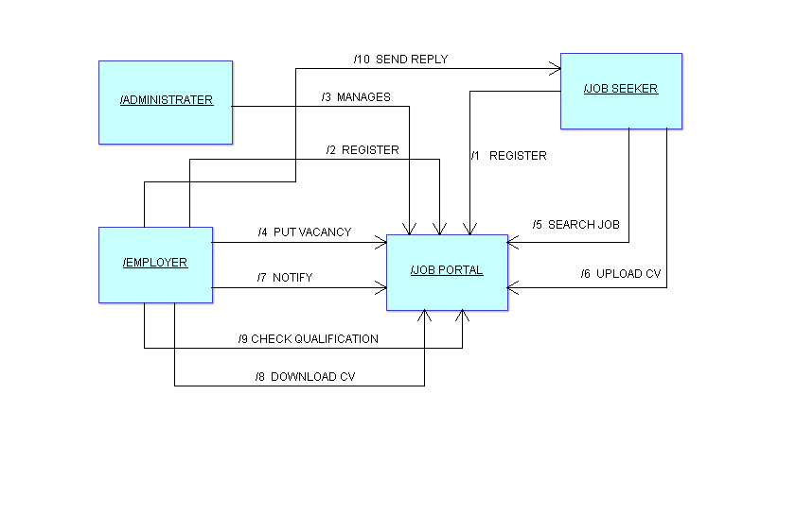

## 3.1.4 Class Diagram:

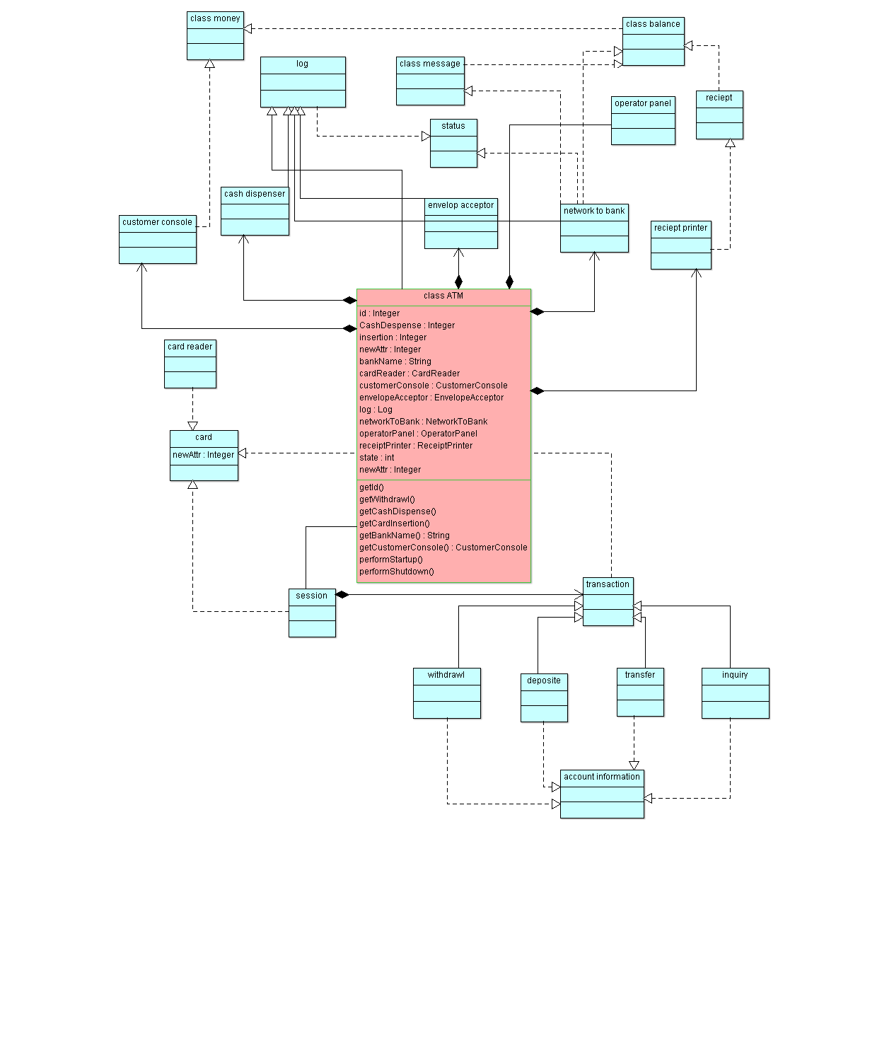

## 3.1.5 Sequence Diagram:

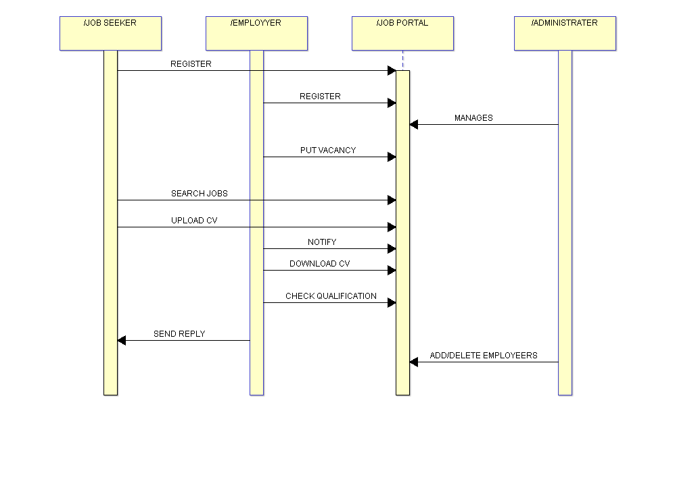

### 

### 3.1.6 Activity Diagram:

### 3.1.6.1 Activity diagram for ADMINISTRATOR:

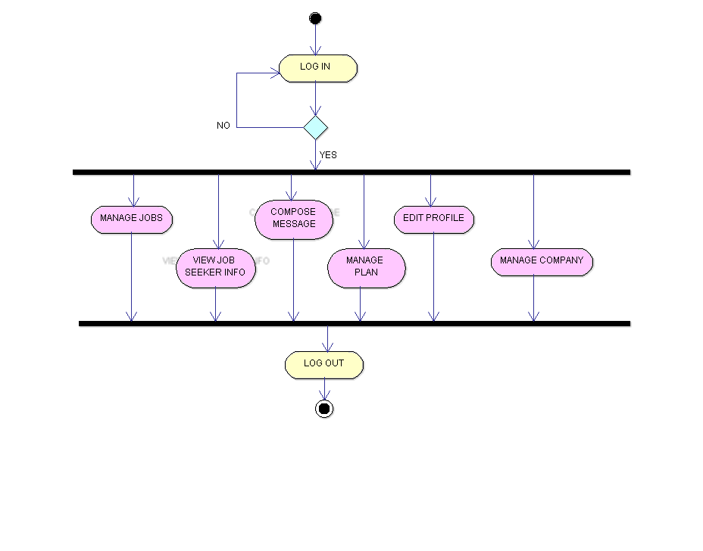

3.1.6.2 Activity diagram for JOB SEEKER: 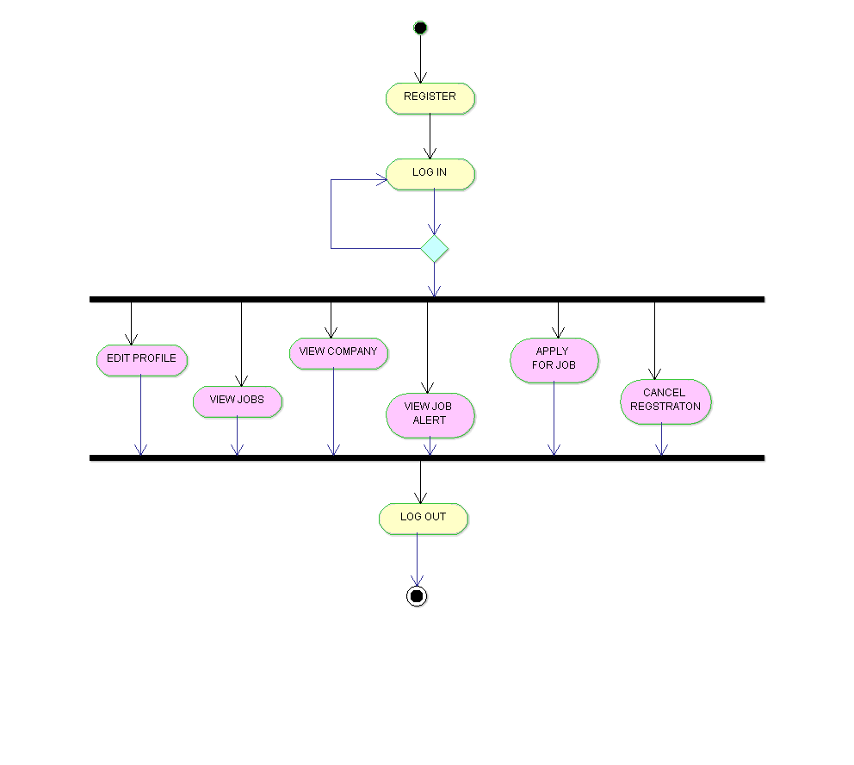3.1.6.3 Activity diagram for EMPLOYER:

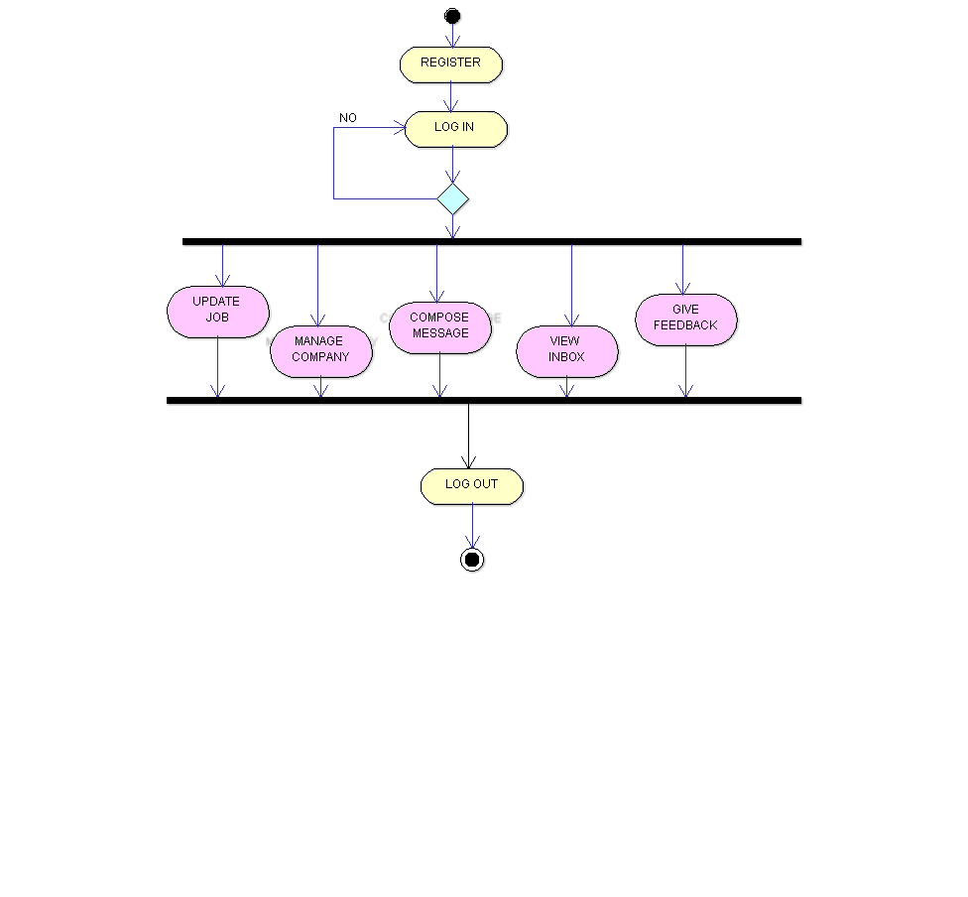

# 3.2 Data Modeling

## 3.2.1 ER Diagram:

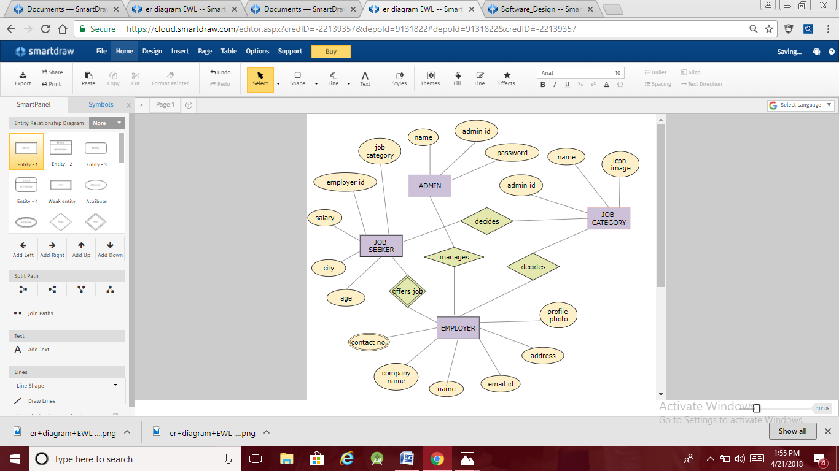

## 3.2.2 Data Flow Diagram:

### 3.2.2.1 LEVEL 0 DATA FLOW DIAGRAM:-

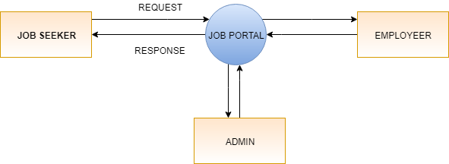

### 3.2.2.2 LEVEL 1 DATA FLOW DIAGRAM:-

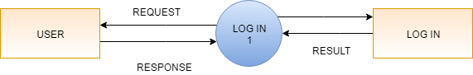

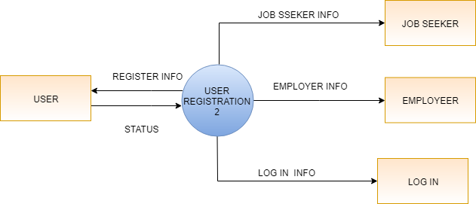

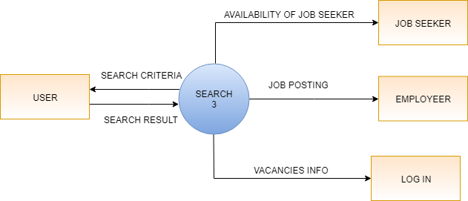

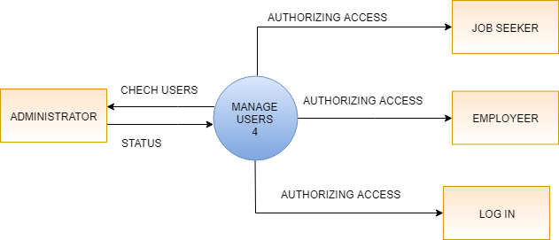

### 3.2.2.1 LEVEL 2 DATA FLOW DIAGRAM:-

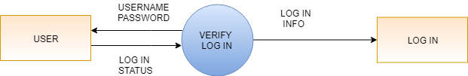

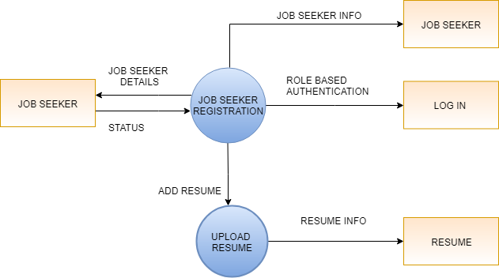

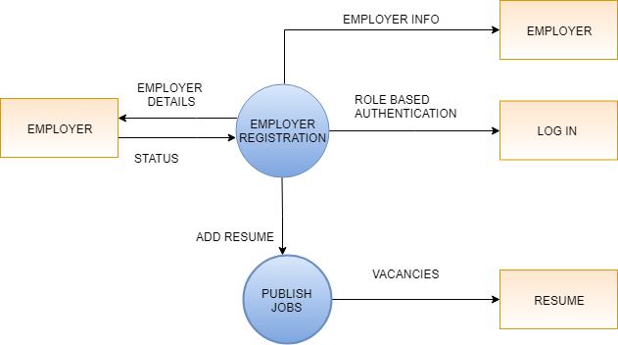

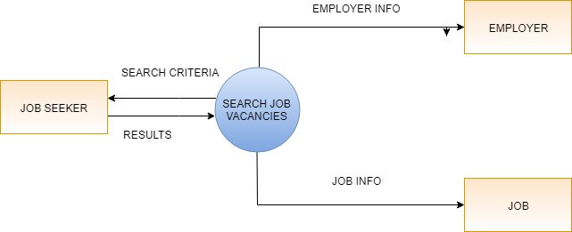

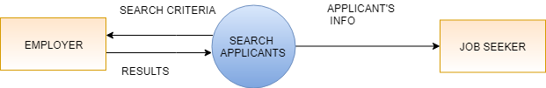

**CHAPTER 4**

**IMPLEMENTATION**

# 4.1 Tool Used:

**Sublime text Editor:**

Feature of sublime text editor:-

* Go to anything (jump to any line, symbol and words.)
* Multiple selection (allow us to change multiple line at once, renaming of variable.)
* Command palette(holds infrequently used functionality(sorting, changing syntax))
* Powerful API and allows us (python API) plugins to augment built-in functionality.
* package ecosystem providing simple access to thousands of packages built by the community
* Split editing allows us to edit with multiple window and multiple splits in each window.
* Instant project switching in sublime.

# 4.2 Testing:

## 4.2.1 Testing Approach:

### 4.2.1.1 White box testing: White Box Testing is the testing of a software solution's internal coding and infrastructure, standard procedure and guidelines. It focuses primarily on security, the flow of inputs and outputs through the application, and improving design and usability.

### White box testing is also known as Clear Box testing, Open Box testing, Structural testing, Transparent Box testing, Code-Based testing, and Glass Box testing.

The term "white box" means, see-through box concept. White box testing, we have divided it into **two basic steps**:

* Understand the source code.
* Create test cases and execute

White box testing techniques includes:

* Control flow testing
* Data flow testing
* Branch testing
* Decision testing
* Modified condition/decision coverage
* Prime path testing
* Path testing

4.2.1.2 Black box testing: The "black box" symbolizes not being able to see the inner workings of the software so that only the end-user experience can be tested. Black Box testing, involves testing from an external.

Black box testing is a software testing techniques in which functionality of the software under test (SUT) is tested without looking at the internal code structure, implementation details and knowledge of internal paths of the software. It is based on the software requirements and specifications.

**Typical Black Box testing Design Techniques includes:**

* **Decision table testing**
* **All pairs Testing**
* **Equivalence Partitioning**
* **Boundary value analysis**
* **Cause-effect graph**
* **Error Guessing**

4.2.1.3 UNIT TESTING: It is a level of software testing where individual units/ components of a software are tested. A unit is the smallest testable part of any software. It usually has one or a few inputs and usually a single output. Unit testing frameworks, drivers, stubs, and mock/ fake objects are used to assist in unit testing.

## 4.2.1.4. Integration Testing: **Integration Testing** is a level of software testing where individual units are combined and tested as a group. The purpose of this level of testing is to expose faults in the interaction between integrated units. Test drivers and test stubs are used to assist in Integration Testing.

Any of [Black Box Testing](http://softwaretestingfundamentals.com/black-box-testing/), [White Box Testing](http://softwaretestingfundamentals.com/white-box-testing/) and [Gray Box Testing](http://softwaretestingfundamentals.com/gray-box-testing/) methods can be used. Various approaches are used for integration testing:

* Big Bang Approach
* Top Down Approach
* Bottom Up Approach
* Sandwich/Hybrid Approach (Top Down Approach + Bottom Up Approach)

4.2.1.5. System Testing: **System Testing**is a level of software testing where complete and integrated software is tested. The purpose of this test is to evaluate the system’s compliance with the specified requirements. [Black Box Testing](http://softwaretestingfundamentals.com/black-box-testing/) method is used. System Testing is the third [level of software testing](http://softwaretestingfundamentals.com/software-testing-levels/) performed after [Integration Testing](http://softwaretestingfundamentals.com/integration-testing/) and before [Acceptance Testing](http://softwaretestingfundamentals.com/acceptance-testing/).

4.2.1.6 Acceptance Testing: Acceptance Testing is performed to confirm that the product is ready to be made available to the end-users. [Black Box Testing](http://softwaretestingfundamentals.com/black-box-testing/) method is used in it. It is the fourth and last [level of software testing](http://softwaretestingfundamentals.com/software-testing-levels/). In it system is tested for acceptability. The purpose of this test is to evaluate the system’s compliance with the business requirements and assess whether it is acceptable for delivery.

4.2.1.7 Regression testing: Regression testing is the process of testing changes to computer programs to make sure that the older programming still works with the new changes. It is done by code testing specialists. Whenever a software product is updated with new code, feature or functionality, it is tested thoroughly to detect if there is any negative impact of the added code.

## 4.2.2 TEST CASES:

IEEE defines test case as “ a set of input values, execution preconditions, expected results and execution post conditions, developed for a particular objective or test condition such as to exercise a particular program path or to verify compliance with a specific requirement.”Generally, a test case is associated with details like identifier, name, purpose, required inputs, test conditions, and expected outputs.

### 4.2.2.1 REGISTRATION:

#### 4.2.2.1.1 TEST CONDITION: E-MAIL

EXPECTED OUTPUT: E-mail format must be input.

TOTAL OUTPUT: E-mail format must be input.

PASS/FAIL: pass

#### 4.2.2.1.2 TEST CONDITION: CONFIRM PASSWORD

EXPECTED OUTPUT: Password and confirm password match.

TOTAL OUTPUT: Password and confirm password match.

PASS/FAIL: Pass

#### 4.2.2.1.3 TEST CONDITION: TEXT FIELD

EXPECTED OUTPUT: All information must be input

TOTAL OUTPUT: All information must be input

PASS/FAIL: pass

#### 4.2.2.1.4 TEST CONDITION: PINCODE

EXPECTED OUTPUT: Pin code must be 6 digits

TOTAL OUTPUT: Pin code must be 6 digits

PASS/FAIL: Pass

#### 4.2.2.1.5 TEST CONDITION: MOBILE NUMBER

EXPECTED OUTPUT: Must be a digit

TOTAL OUTPUT: Must be a digit

PASS/FAIL: Pass

### 4.2.2.2 LOG IN :

#### 4.2.2.2.1 TEST CONDITION: NON REGISTERED USER

EXPECTED OUTPUT: The System will not allow Non Registered User to Login

TOTAL OUTPUT: Non-Registered user can not Login

PASS/FAIL: Fail

#### 4.2.2.2.1 TEST CONDITION: WRONG USER NAME AND PASSWORD

EXPECTED OUTPUT: The system displays an Error Message, prevents from Login.

TOTAL OUTPUT: The system displays an Error Message “Invalid User Name or Password”, prevents from Login

PASS/FAIL: Fail

#### 4.2.2.2.1 TEST CONDITION: ENTER CORRECT USER NAME AND PASSWORD

EXPECTED OUTPUT: The system updates Session variables and redirect to home page.

TOTAL OUTPUT: The System Display Home Page for User/Admin

PASS/FAIL: Pass

#### 4.2.2.2.2 CHANGE PASSWORD:

TEST CONDITION: Change password

EXPECTED OUTPUT: If User Want To Change Password, Password Will Change.

TOTAL OUTPUT: The System Updates Password after Verifying Old password.

PASS/FAIL: Pass

## 4.3 USER MANUAL:

**Chapter 5**

**Project Plan**

# 5.1 Gantt Chart:

|  |  |  |  |
| --- | --- | --- | --- |
| **TASK**  **(ACCOMPLISHED)** | **DURATION**  **(DAYS)** | **STARTING DATE** | **TERMINATION DATE** |
| **TOPIC FINALIZATION** | 6 | 13/02/2018 | 19/02/2018 |
| **LITERATURE SURVEY** | 6 | 20/02/2018 | 26/02/2018 |
| **UML DIAGRAMS** | 10 | 27/02/2018 | 7/3/2018 |
| **FRONT END CODING** | 11 | 7/3/2018 | 17/03/2018 |
| **BACK END DEVELOPMENT** | 4 | 18/03/2018 | 22/03/2018 |
| **DATABASE DESIGNING** | 7 | 22/03/2018 | 29/03/2018 |
| **BACKEND CODING** | 23 | 30/03/2018 | 22/04/2018 |
| **USER INTERFACE** | 7 | 5/4/2018 | 22/04/2018 |
| **DOCUMENTATION** | 48 | 5/3/2018 | 23/04/2018 |
| **TOTAL** | 74 |  |  |

|  |  |  |  |  |  |  |  |
| --- | --- | --- | --- | --- | --- | --- | --- |
| DEVELOPMENT  PHASE | 0-15  DAYS | 15-30  DAYS | 31-45  DAYS | 46-60  DAYS | 60-75  DAYS | 76-90  DAYS | DURATION  (DAYS) |
| REQUIREMENT GATHERING |  |  |  |  |  |  |  |
| **ANALYSIS** |  |  |  |  |  |  |  |
| **DESIGN** |  |  |  |  |  |  |  |
| **CODING** |  |  |  |  |  |  |  |
| **TESTING** |  |  |  |  |  |  |  |
| DEPLOYMENT  AND  IMPLEMENTATION |  |  |  |  |  |  |  |
| **DOCUMENTATION** |  |  |  |  |  |  | **PARALLEL** |
| TOTAL TIME  (DAYS) |  |  |  |  |  |  | **90** |

# 5.2 Effort Schedule & Cost Estimation :

# 5.3 Work Breakdown Structure:

**Chapter 6**

**Conclusion**

**AND**

**Future Scope**

# Conclusion:

Here we have design a project earn while learn. All the application codes is in HTML, CSS, BOOTSTRAP, with back end coding in “ruby on rails”. This portal provides all the features with support of extension and its functionality is limited.

Our project satisfies all the functional requirements mentioned in the project and in future we are going to add some more functionality in this project like.

* Online Payments.
* Chat between Employer and jobseeker (text or audio).
* Review and ratings for the employer’s by job seekers.
* Other than these jobs there will be many other job for themes, according to their education and qualification.

This project is completed but still we want to update and modify some modules. We are always thinking about Guest requirements also growing day by day.

# Future Scope:

The scope this product is to provide a system where;

* The job seekers will have an easy access to the different opportunities available in the IT world, apart from those that are available through the campus placements.
* The recruiters will have access to a quality candidate poll.
* Various part-time job opportunities are provided to the students within the campus. The part-time student employees could work as Library Assistants, Computer Service Assistants, Data entry Operators, Project/Lab Assistants, Assistant Coaches/Trainers and Career Counselors.
* The college provides its budding entrepreneurs with necessary guidance and resources to initiate and run their entrepreneurial ventures as well as provides for incubation of their business ideas.
* Promising service provisions.

**BIBLIOGRAPHY**

# REFERENCES:

[https://www.youtube.com/watch?v=8jabQ9Ttf5c#action=share](https://www.youtube.com/watch?v=8jabQ9Ttf5c" \l "action=share) (MVC architecture)

<https://www.tutorialspoint.com/ruby-on-rails/rails-framework>

<https://youtu.be/jG98Od819og> (ruby on rails tutorial on gemfile and bundle)

<https://www.w3schools.com/>

<https://en.wikipedia.org/wiki/Class_diagram>

* During the development of our system, we have taken the reference from various books and journals.
* Books :

# Software Engineering: A Practitioner's Approach 8th Edition.

# APPENDIX A: SNAPSHOTS OR SCREENSHOTS WITH DESCRIPTION:

## HOME PAGE FOR EARN WHILE LEARN:

Home page gives us idea about a button for browsing and overview of jobs. And some of the jobs available .Also some information about the site, contact details information Buttons.

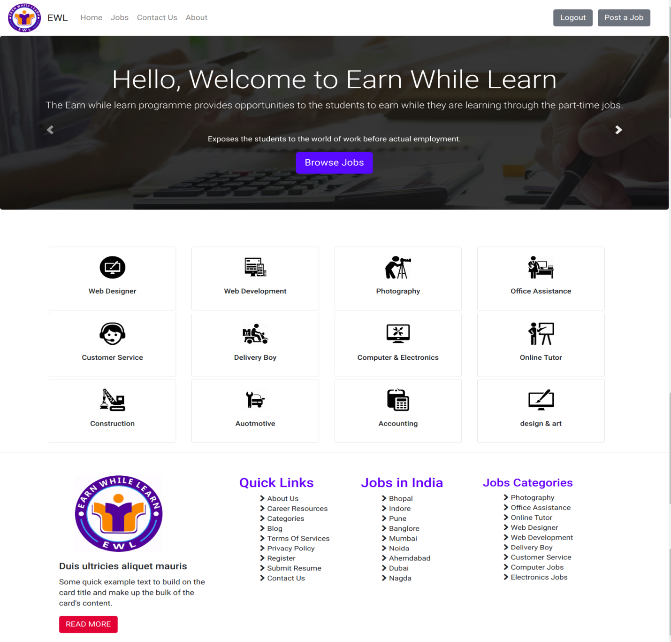

1. LOG IN FORM:

One can log in authentically to the site as per security purposes we have use a username and password to make it accessible only for the authentic users.

One can sign up if is not logged in. By clicking at “sign up” at the lower side of the form.

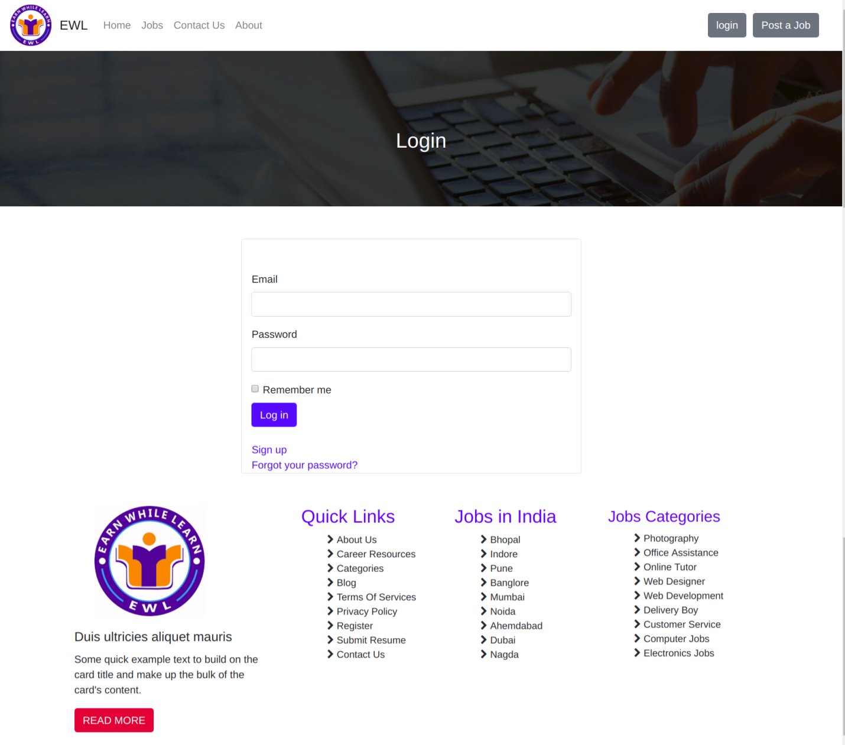

1. SIGN UP FORM:

If not logged in one can go for sign up, filling the following form with the query details can go for signed up to the website.

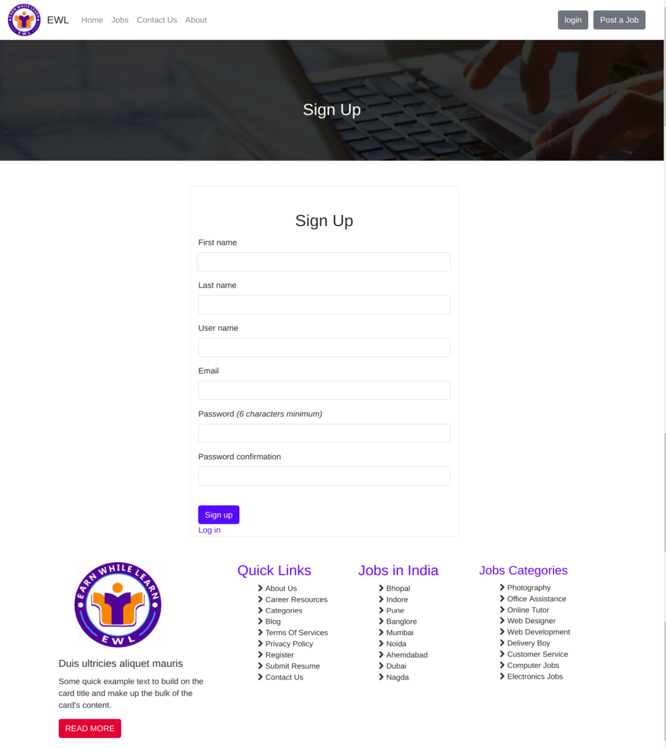

# Contact details:

The details available at “contact us” will help the users to match the perfect location of the company. It contains the information about phone number, address, location (by gem geo coder), sending any message, e-mails, to search for a location will help the user a lot.

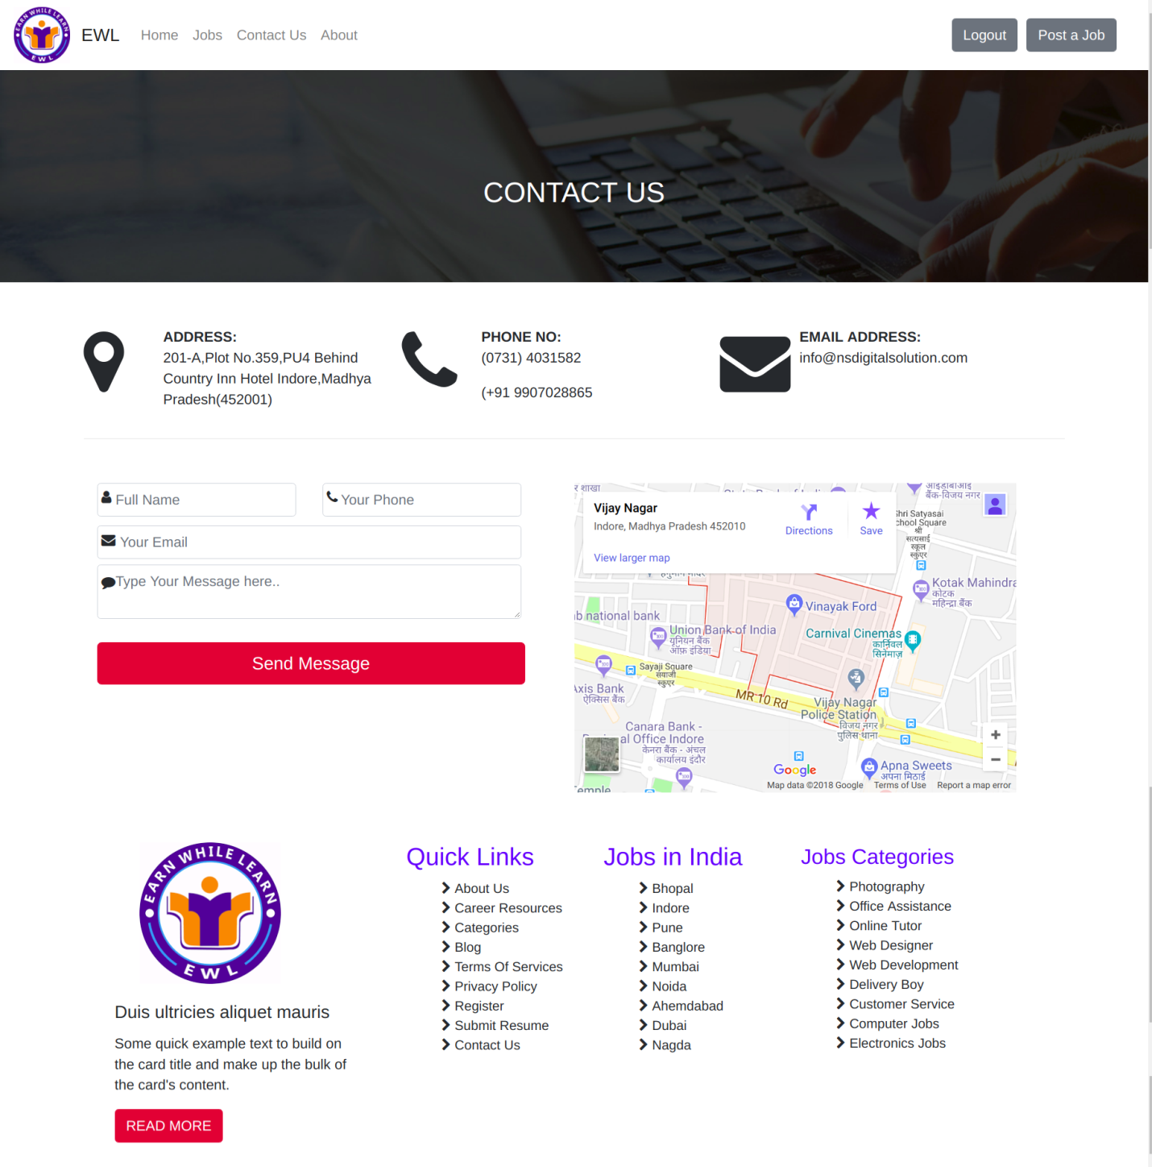

1. Browsing a job:

Anyone can browse a job on this site means can go for overviews of available jobs. A button available on home page migrates for browsing a job.

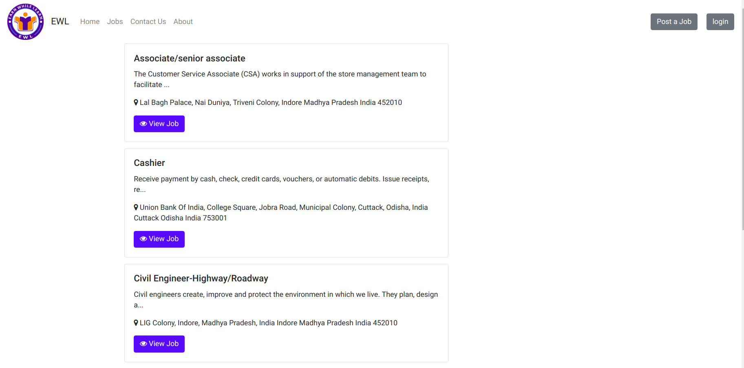

# VIEW THE AVAILABLE JOBS (VIEW JOBS):

One can view specifically a job by clicking on “view job” button. Any job he/she found suitable for them, they will go for getting full information about that job.

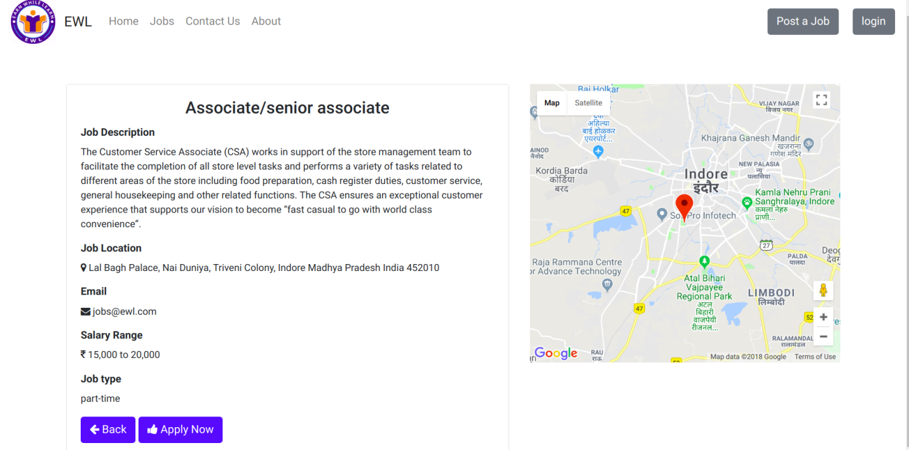

# APPLY FOR JOB:

By clicking on “Apply now” button one can apply for job and the person will have to fill a form. Where one can set his/her profile picture and can submit.

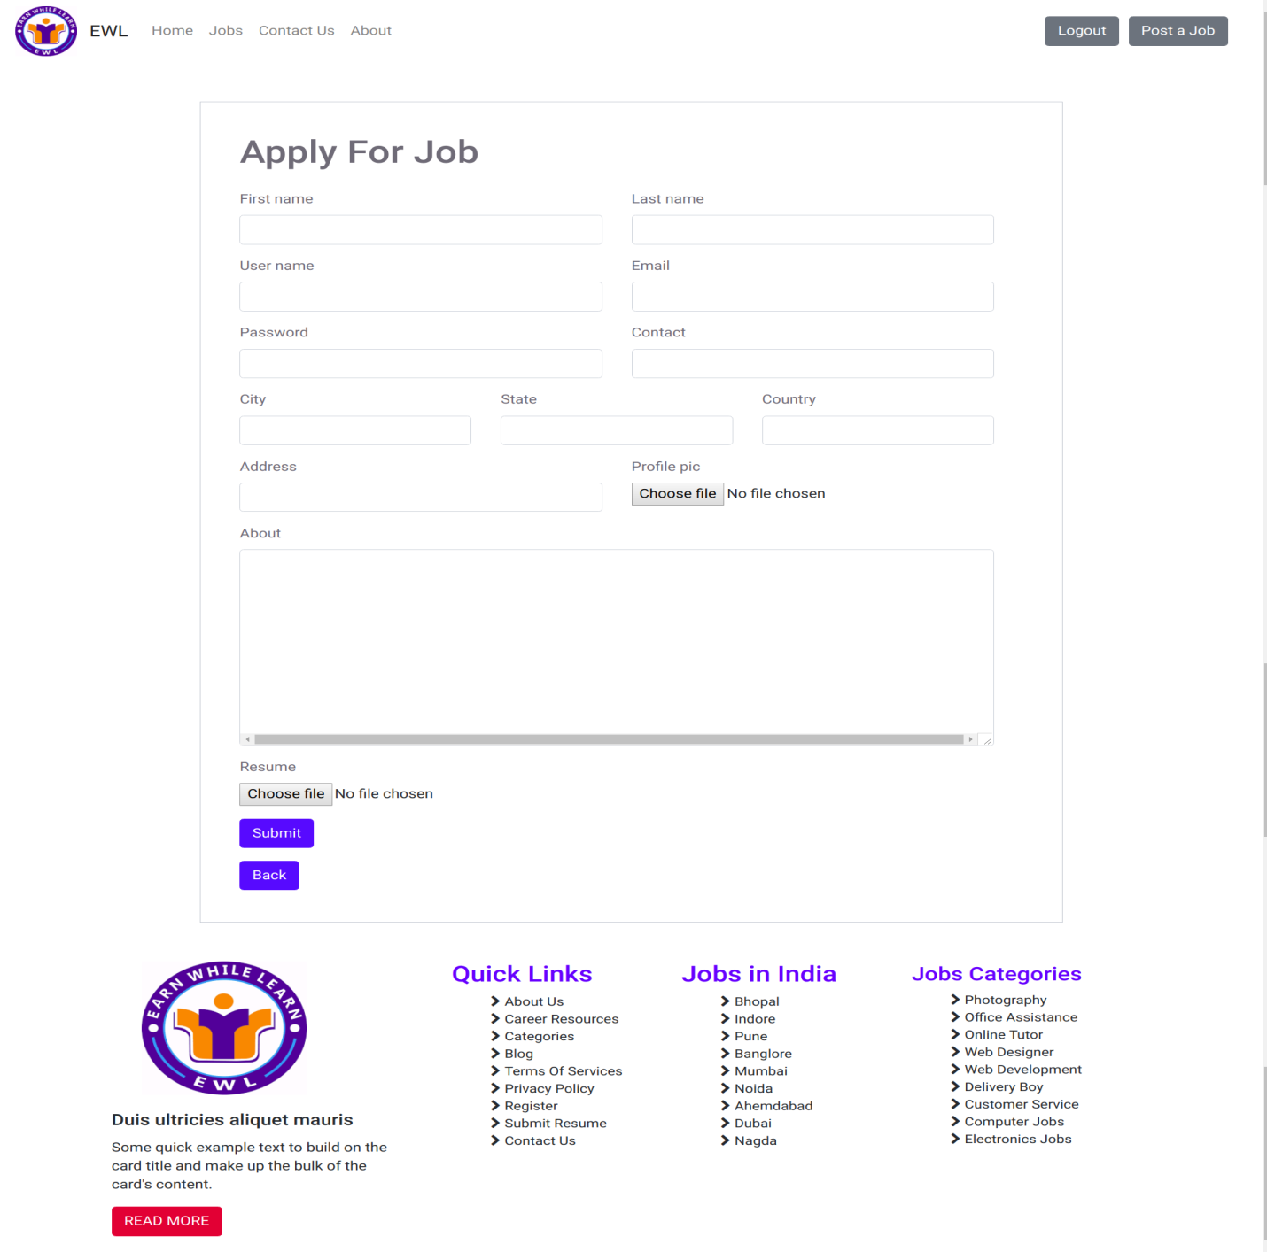

# JOB SEEKERS, WHO HAVE APPLIED FOR JOB :

Employer can view who are the candidates, those have apply for getting job, along with their profile, date& time. Employer can see their report (resume) and profile that was uploaded by job seeker.

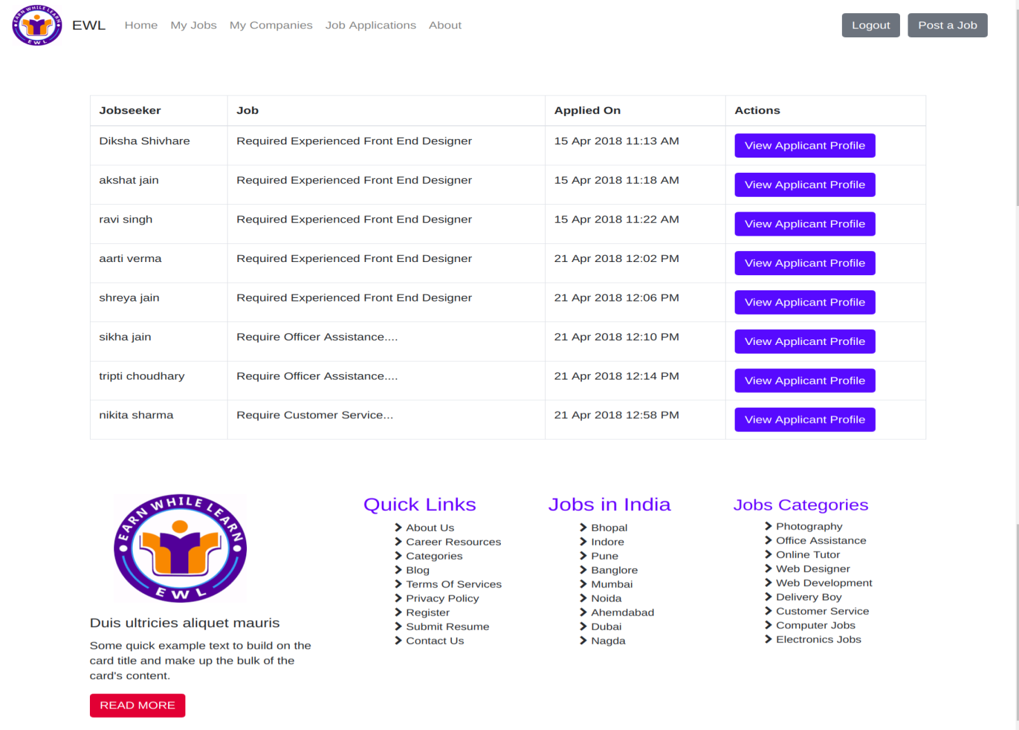

# CREATE NEW COMPANY:

Any new company after log in or sign in, can register their own companies to getting employees for their company.

So they will have to fill the following form and then can register for posting jobs on the website.

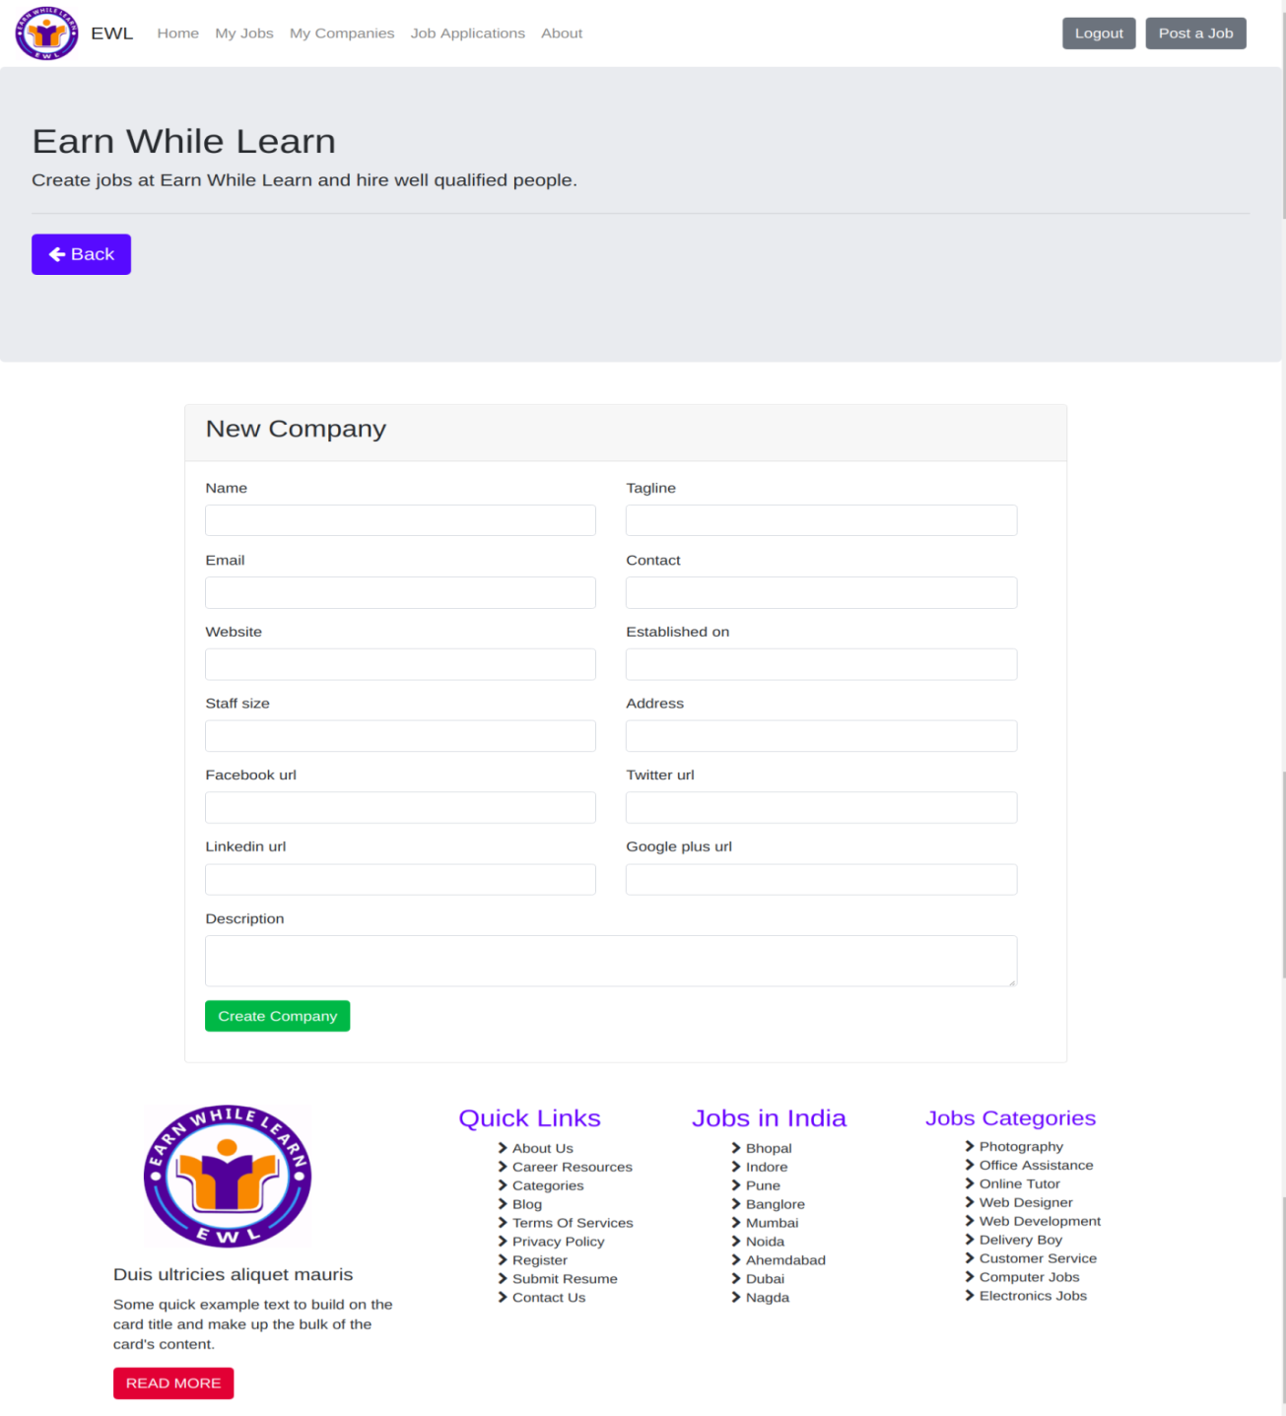

# Create job:

Any new company those who have created profile on the website for their company by filling the mentioned form, can post job on the website by filling the following form and can create job so that anyone can vies this job and can apply for it.

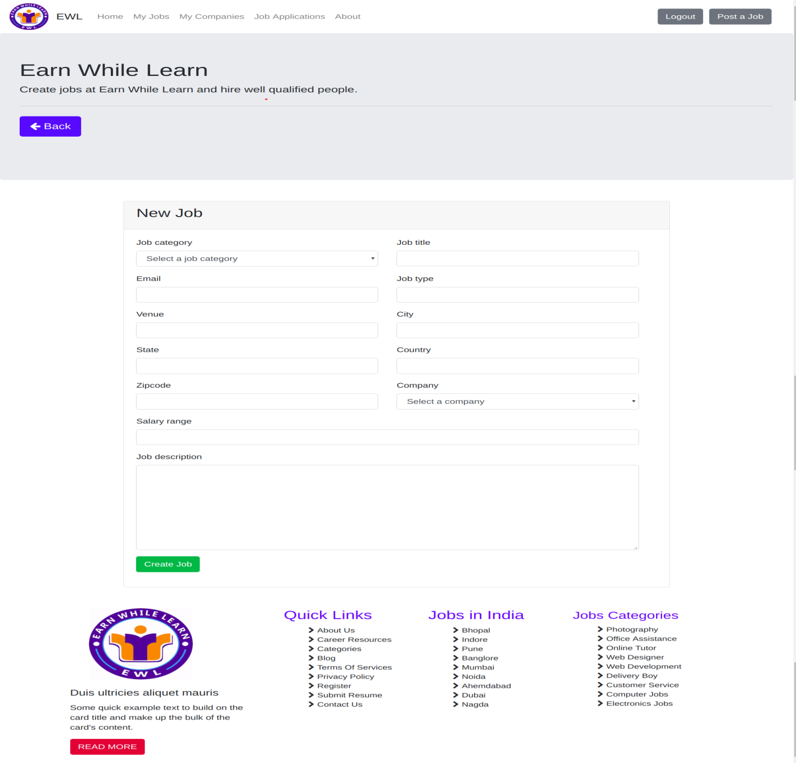

# JOB SEEKER’S DETAIS:

As Employer can view the list of candidates who had applied for the posted job. So Employer can also view any candidate’s information (profile) or any applicant’s profile that job seeker had posted on the website for the specific job. Admin can also view these posts.

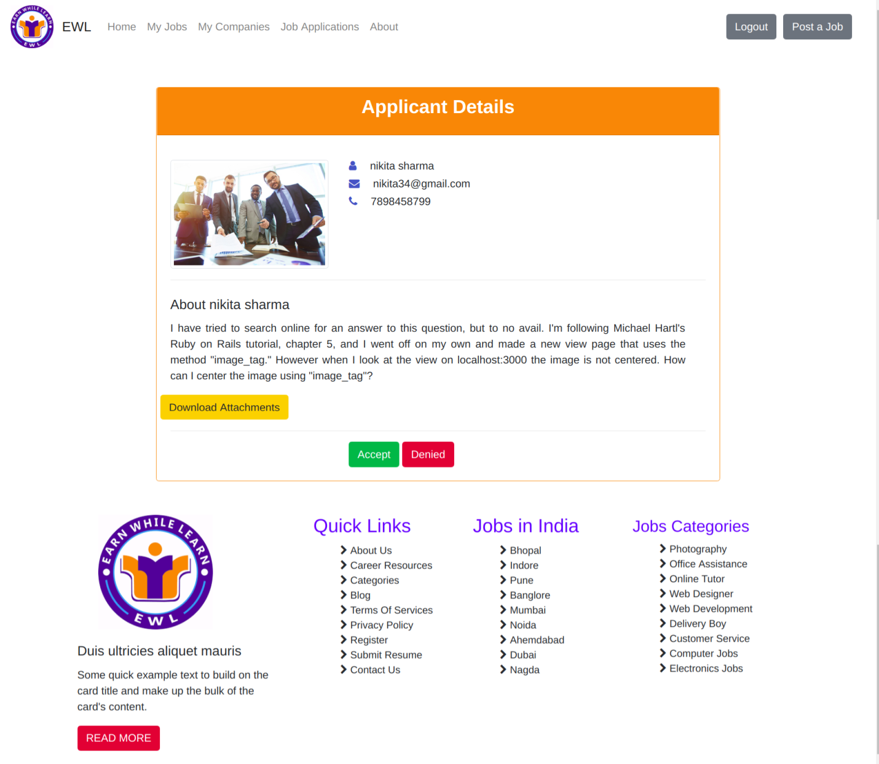

# SHOW COMPANY:

One can see the list of company registered on the website. Employer and admin as well as job seeker can view this list, along with the contact details, e-mail and name of the employer form the company.

Authentic user like employer of the same company or admin can edit the company’s details and can delete it also afterwards sending an e-mail to that company. one can also add new company.

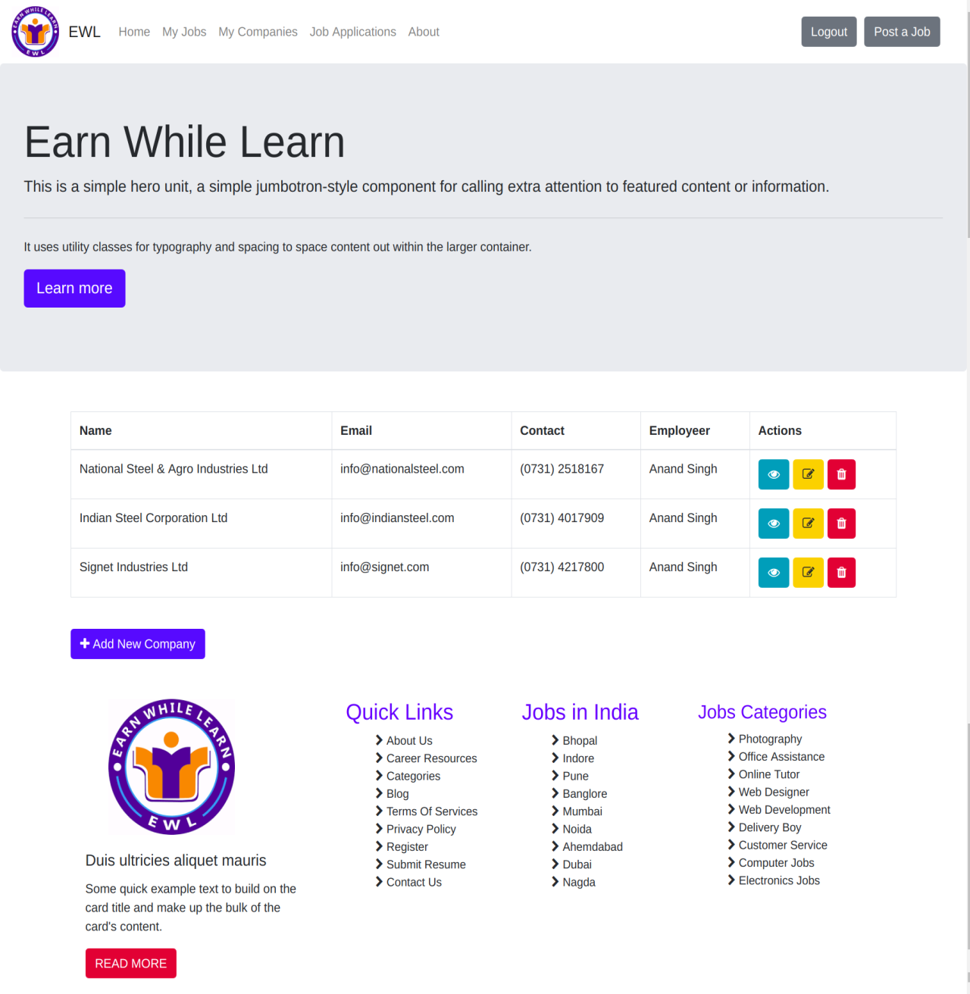

1. SHOW JOBS:

What are the available jobs one can browse it and can and can look about salary, which type of job it is? Employer can post these jobs and can add new job according to their need.

